JIRA:

Development of netbanking application:

EPIC:

User stories creation:

Below are the user stories created

**DNA-7, DNA-8, DNA-10, DNA-11**

Backlog creation:

Spirnt planning:

Sprint execution:

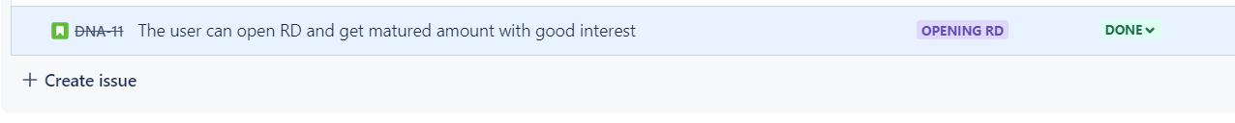

Import testcases from excel:

Imported successfully.

